# Reeksamen 2022 - Signaler og systemer

Af Jesper Bertelsen

Indholdsfortegnelse

Reeksamen 2022 - Signaler og systemer 1

Question 1. (20 points) 1

Question 2. (20 points) 5

Question 3: (20 points) A linear time-invariant (LTI) system is described by the following differential equation: 10

Question 4: (20 points) 12

Opgave 5. (20 points) 15

## Question 1. (20 points)

1. (10 points) Determine whether or not each of the following signals is periodic. Justify all your answers with necessary calculations. If it is periodic, determine the fundamental period. (Computer plots are neither needed nor accepted as an answer.)

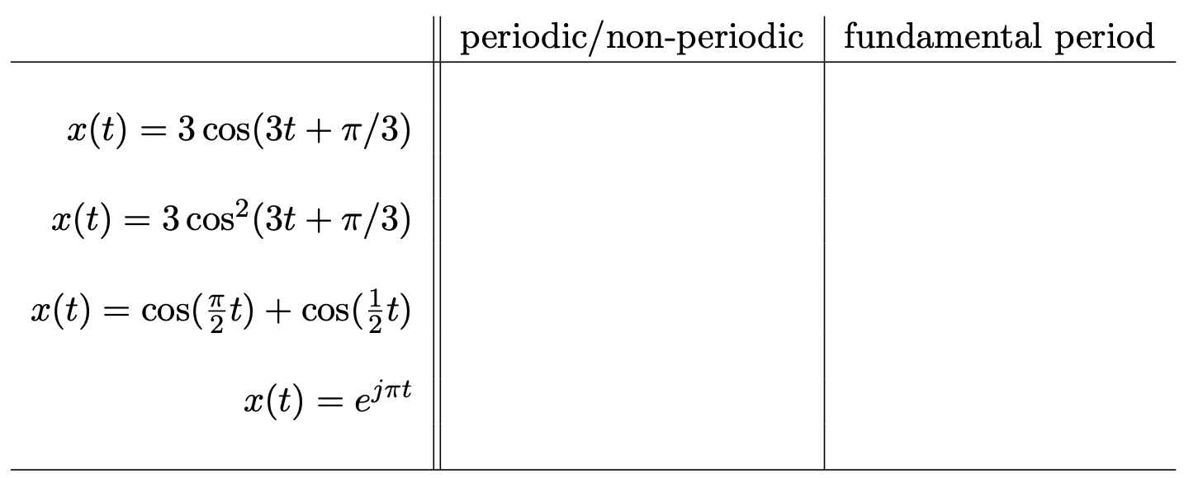



1. So, for the first one, it’s clearly a periodic system as the signal is of only a cos signal, which I know will repeat itself after a period.

================

================

1. 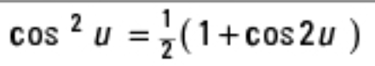The next one is a little tricky as the cos function is powered by to.

I found this relationship:

Which helps a lot:

is just a offset in amplitude. In signals this might be a DC voltage or some noise highering the voltage.

The fundamental frequency in and fundament period are:

===============

===============

1. The third signal we have to test.

The sum of signals can be periodic, but I can put that to the test.

If

Then the signal is periodic

can’t be written as a rational number, so nether can the above.

=================

The signal is aperiodic

=================

1. The fourth and last one is

For simplicity sake I will write this in terms of cos and sin.

And that’s just two signals. I know that complex exponential functions are periodic, and I see that they share the same frequency.

Just for the sake of formularity I will take the Lowest Common Multiple(LCM) to find the fundamental period and then find the fundamental frequency.

Så med det så må frekvensen være:

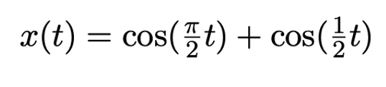

1. 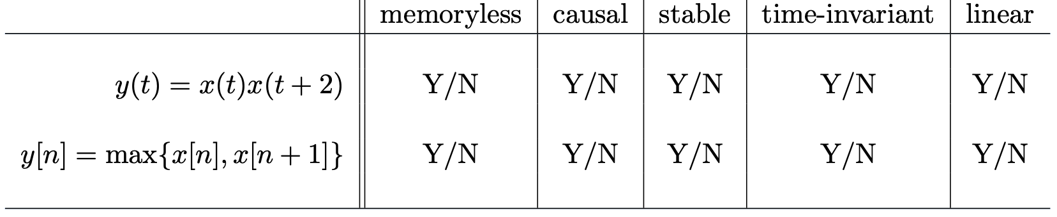(10 points) Determine whether or not the following systems are memoryless, causal, stable, time-invariant, and/or linear. Y and N stand for Yes and No, respectively. Justify all your answers with necessary explanations.



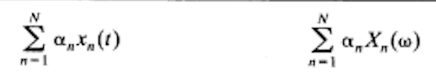



The linearity for the last one must be a yes. The function only picks one of the signals. And for it to be linear its frequency transfer function must have the same coefficients as its time function, and I don’t see why it shouldn’t with only the one signal.

## Question 2. (20 points)

Determine the Fourier series representation of the following signal with the period T = 4:

‘’’



I will use the analysis equation to derive a simpler function for the transfer function:

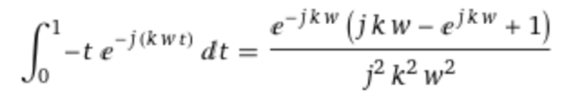So we have two functions to integrate.

Ny strategi, ændre til cos/sin så tidligt som muligt.

For simpliciteten laver jeg en konstant

Integration by parts:

Jeg følger rækkefølgen ILATE for hvilken funktion der skal være u

Inverse, Logaritmisk, Algebraisk, Trigonometrisk, Exponentiel

Så derfor vælger jeg u som t

Og så laver jeg de eksponentielle funktioner til cos og sinus funktioner. Jeg laver en ny funktion i stedet for c

Og når jeg ser på det så

Så jeg kan lave to funktioner

*Lige:*

For lige tal:



*Ulige:*

For ulige tal:



So I’ve two functions describing the signal.

To find all coefficient, estimate the signal and plot them all, I’ve made helper functions.

My script in python with my helper functions:

What the graphs indicates is at the top, the real numbers of coefficients from the fourier series.

At the bottom we see the actual function and the approximations.

It looks like, that I’ve derived the wrong formular for coefficients, as the approximation approaches a different function when , then the given function.

A square function with symmetry around it’s axes is easy to derive.

I randomly made the on value be 1, but the coefficients approaches the

This was how the ramp and step function should have been too.

## Question 3: (20 points) A linear time-invariant (LTI) system is described by the following differential equation:

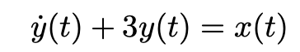

where x(t) represents the input signal and y(t) represents the output signal.

1. (5 points) Determine the frequency response of the system.

If I assume, that the input can be described as a complex exponential signal with a fundamental frequency I can describe the rest

Implicit solution !

The output is modified by a frequency response

Making

with

And then I can write it all in terms of the signal.

Then I can cancel the input signal out from both sides.

General solution

If my assumption of the signal being represented with the complex exponentiel to a fundamental frequency isn’t sufficient, which I think it could be, but then this would be a general solution.

1. (5 points) Sketch the Bode plot of the system.

With the system being the implicit one I made, I got this sketch:

1. (10 points) Determine the output y1(t) when the input is:

From my derived general solution:

================

================

When that’s said and done I used laplace to solve the equation:

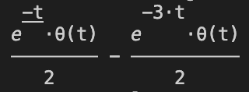My script:

Figure : The results

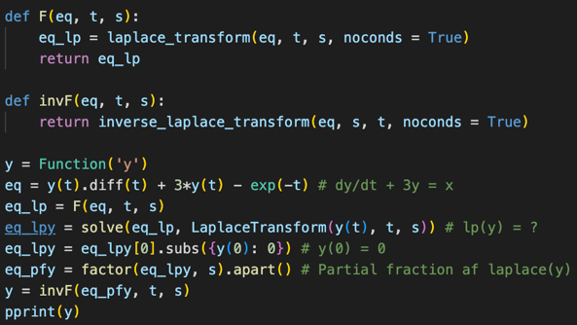

For my knowledge about differential equations can be composited by the sum of linear independent solutions.   
From my calculations I found that

, which is confirmed by my solution from laplace transforms.

However, I found a solution more with the laplace transform.

I guess both answers are right, but I can conclude that the first solution and the total output is:

==============

==============

## Question 4: (20 points)

(a) Consider a discrete-time linear time-invariant (LTI) system with the impulse response .

The following input signal is considered: x[n] = u[n] − u[n − 3]

1. (3 points) Sketch the signals h[n] and x[n].



1. (7 points) Sketch the output signal y[n] for the input x[n].( y[n] = x[n] ∗ h[n])

u[n] is the unit step function in discrete-time.

The doesn’t matter, as the will be either 0 or 1.

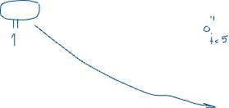

(b) Consider a continuous-time LTI system with the impulse response h(t) = u(t) − u(t − 5). The following input signal is considered: x(t) = u(t) − u(t − 3).

1. (3 points) Sketch the signals h(t) and x(t).

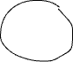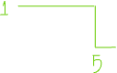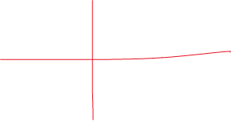

1. (7 points) Sketch the output signal y(t) for the input x(t). y(t) = x(t) ∗ h(t) u(t) is the unit step function in continuous-time.

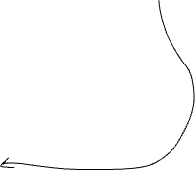

As seen in previous one, the output can be interpreted from the sketch of the input and the impulse response.

The input and the response both have a magnitude of 1 and is nonzero until 3.



## Opgave 5. (20 points)

(a) (11 points)

A continuous-time causal LTI system is characterized by the differential equation,

where x(t) represents the input signal and y(t) represents the output signal.

1. Find H(s), the Laplace transform of the impulse response, h(t), of the system.

I will find a laplace expression for y(s) and then for x(s) and then get the H(s) from

I am using sympy to do the calculation, but the math behind this is, that I replace the derivatives

Continuing until there is no longer any derivatives left.   
The step after that is to isolate the laplace transform of the variable I want and then inverse laplace transform both sides.

I know that the output can be written as

For this I have as my two parts of a product in my denominator

If I choose some values for s I will find the derive A and B

Now for

So I have my partial fraction composition now:

===========================================================

===========================================================

An idea:

And then I choose that

==============================================================

==============================================================

I think wordmat have given up on me at this point, the solution is not 50. Too bad.   
Compared to the manual above, I wrote it in terms of into python and got:

I think both answers are false, but this was my way to try to find the answer.

1. Specify the region of convergence (ROC), poles, and zeros of H(s) on a plot.

(b) (9 points)

Sketch the corresponding region of convergence (ROC) in each pole-zero plot below, considering the statements about x(t).

1. x(t) is absolutely integrable.
2. x(t) = 0, for t < −2. (I.e., the signal is right-sided.)
3. x(t)e3t is absolutely integrable. (Hint: Use the property of shifting in the s-domain)